®  34-36 Peyo Yavorov blvd,  Sofia 1164, Bulgaria | tel +359 2 423 4455  proektsoft.bg@gmail.com  https://calcpad.eu

A CALCPAD PROGRAM

FOR ANALYSIS OF PLANE FRAMES
WITH VARIABLE CROSS-SECTIONS

─◊─◊──◊───◊────⧫────◊───◊──◊─◊─

(using the finite element method)

by

Eng. Nedelcho Ganchovsky
Table of contents
I. Introduction 1
II. Calcpad source code 2
III. Output 12
IV. Comparison with SAP 2000 21
V. Conclusions 25

Introduction
This Calcpad program performs analysis of plane frames with variable cross-sections using the finite element method. The input data is entered in text format as vectors and matrices as follows:
- joint coordinates;
- joint numbers at the ends of the elements;
- material properties;
- dimensions and types of cross-sections;
- support conditions;
- load values.
As a result, diagrams of internal forces and deflections of structural elements are obtained. The schemes are automatically generated by the program, using the SVG graphical format.

Calcpad source code
1  2  3  4  5  6  7  8  9  10  11  12  13  14  15  16  17  18  19  20  21  22  23  24  25  26  27  28  29  30  31  32  33  34  35  36  37  38  39  40  41  42  43  44  45  46  47  48  49  50  51  52  53  54  55  56  57  58  59  60  61  62  63  64  65  66  67  68  69  70  71  72  73  74  75  76  77  78  79  80  81  82  83  84  85  86  87  88  89  90  91  92  93  94  95  96  97  98  99  100  101  102  103  104  105  106  107  108  109  110  111  112  113  114  115  116  117  118  119  120  121  122  123  124  125  126  127  128  129  130  131  132  133  134  135  136  137  138  139  140  141  142  143  144  145  146  147  148  149  150  151  152  153  154  155  156  157  158  159  160  161  162  163  164  165  166  167  168  169  170  171  172  173  174  175  176  177  178  179  180  181  182  183  184  185  186  187  188  189  190  191  192  193  194  195  196  197  198  199  200  201  202  203  204  205  206  207  208  209  210  211  212  213  214  215  216  217  218  219  220  221  222  223  224  225  226  227  228  229  230  231  232  233  234  235  236  237  238  239  240  241  242  243  244  245  246  247  248  249  250  251  252  253  254  255  256  257  258  259  260  261  262  263  264  265  266  267  268  269  270  271  272  273  274  275  276  277  278  279  280  281  282  283  284  285  286  287  288  289  290  291  292  293  294  295  296  297  298  299  300  301  302  303  304  305  306  307  308  309  310  311  312  313  314  315  316  317  318  319  320  321  322  323  324  325  326  327  328  329  330  331  332  333  334  335  336  337  338  339  340  341  342  343  344  345  346  347  348  349  350  351  352  353  354  355  356  357  358  359  360  361  362  363  364  365  366  367  368  369  370  371  372  373  374  375  376  377  378  379  380  381  382  383  384  385  386  387  388  389  390  391  392  393  394  395  396  397  398  399  400  401  402  403  404  405  406  407  408  409  410  411  412  413  414  415  416  417  418  419  420  421  422  423  424  425  426  427  428  429  430  431  432  433  434  435  436  437  438  439  440  441  442  443  444  445  446  447  448  449  450  451  452  453  454  455  456  457  458  459  460  461  462  463  464  465  466  467  468  469  470  471  472  473  474  475  476  477  478  479  480  481 | #include svg_drawing.cpd  "Analysis of plane frames with variable cross-sections  '<h4>Joint coordinates - xJ; yJ</h4>  #hide  #deg  δz = 10^-12  Precision = 10^-8  x_J = [0; 0; 8; 16; 16]*m  y_J = [0; 8; 10; 8; 0]*m  #show  x_J','y_J  n_J = len(x_J)  '<h4>Elements - [J1; J2]</h4>  #hide  e_J = [1; 2|3; 2|3; 4|5; 4]  #show  transp(e_J)  n_E = n_rows(e_J)  'Element endpoint coordinates  x_1(e) = x_J.e_J.(e; 1)','y_1(e) = y_J.e_J.(e; 1)  x_2(e) = x_J.e_J.(e; 2)','y_2(e) = y_J.e_J.(e; 2)  'Element length - 'l(e) = sqrt((x_2(e) - x_1(e))^2 + (y_2(e) - y_1(e))^2)  'Element directions  c(e) = (x_2(e) - x_1(e))/l(e)','s(e) = (y_2(e) - y_1(e))/l(e)  'Transformation matrix  'Diagonal 3x3 block -'t(e) = [c(e); s(e); 0|-s(e); c(e); 0|0; 0; 1]  'Generation of the full transformation matrix  T(e) = add(t(e); add(t(e); matrix(6; 6); 1; 1); 4; 4)  '<h4>Supports - [Joint; cx; cy; cr]</h4>  #hide  c = [1; 10^20kN/m; 10^20kN/m; 0kNm|5; 10^20kN/m; 10^20kN/m; 10^20kNm]  #show  c  n_c = n_rows(c)  '<h4>Loads - [Element, qx, qy]</h4>  #hide  q = [1; 10kN/m; 0kN/m|2; 0kN/m; -20kN/m|3; 0kN/m; -10kN/m]  n_q = n_rows(q)  q_x = vector(n_E)*kN/m  q_y = vector(n_E)*kN/m  $Repeat{q_x.(q.(i; 1)) = q_x.(q.(i; 1)) + q.(i; 2) @ i = 1 : n_q}  $Repeat{q_y.(q.(i; 1)) = q_y.(q.(i; 1)) + q.(i; 3) @ i = 1 : n_q}  #show  q  'Load values on elements  q_x  q_y  '<h4>Scheme of the structure</h4>  #hide  w = max(x_J)  h = max(y_J)  W = 240  H = h*W/w  k = W/w  #def svg$ = '<svg viewbox="'-3m*k' '-2m*k' '(w + 6m)*k' '(h + 4m)*k'" xmlns="http://www.w3.org/2000/svg" version="1.1" style="font-family: Georgia Pro; font-size:5pt; width:'W + 150'pt; height:'H + 200*H/W'pt">  #def thin_style$ = style = "stroke:green; stroke-width:1; fill:none"  #def thick_style$ = style = "stroke:green; stroke-width:2; fill:none"  k_q = m/kN  #show  #val  svg$  #for i = 1 : n_E  #hide  x1 = x_1(i)*k  y1 = (h - y_1(i))*k  x2 = x_2(i)*k  y2 = (h - y_2(i))*k  q_xi = q_x.i  q_yi = q_y.i  α = atan2(c(i); s(i))  #if α ≥ 135  α = α - 180  #end if  #if α < -45  α = α + 180  #else if α < 0  α = 360 + α  #end if  #if q_xi ≠ 0kN/m  #hide  x3 = x2 - q_xi*k_q','y3 = y2  x4 = x1 - q_xi*k_q','y4 = y1  x = (x3 + x4)/2 - 5*sign(q_xi)  y = (y3 + y4)/2  #show  '<polygon points="'x1','y1' 'x2','y2' 'x3','y3' 'x4','y4'" style="stroke:magenta; stroke-width:1; stroke-opacity:0.3; fill:magenta; fill-opacity:0.1;" />  text$(x;y;α;qx='abs(q_xi)')  #end if  #if q_yi ≠ 0kN/m  #hide  x3 = x2','y3 = y2 + q_yi*k_q  x4 = x1','y4 = y1 + q_yi*k_q  x = (x3 + x4)/2  y = (y3 + y4)/2 + 5*sign(q_yi)  #show  '<polygon points="'x1','y1' 'x2','y2' 'x3','y3' 'x4','y4'" style="stroke:dodgerblue; stroke-width:1; stroke-opacity:0.4; fill:dodgerblue; fill-opacity:0.15;" />  text$(x;y;α;qy='abs(q_yi)')  #end if  #show  line$(x1; y1; x2; y2; main_style$)  #loop  '<g id="frame">  #for i = 1 : n_E  #hide  x1 = x_1(i)*k  y1 = (h - y_1(i))*k  x2 = x_2(i)*k  y2 = (h - y_2(i))*k  #show  line$(x1; y1; x2; y2; main_style$)  #loop  #for i = 1 : n_c  #hide  j = c.(i; 1)  x1 = x_J.j*k  y1 = (h - y_J.j)*k  δ = w/30*k*sign(x1 - w/2*k)  x2 = x1 - δ  y2 = y1 - abs(δ)  x3 = x1 + δ  y3 = y1 + abs(δ)  #show  #if c.(i; 2) ≠ 0kN/m  #if c.(i; 3) ≠ 0kN/m  #if c.(i; 4) ≠ 0kNm  line$(x1; y1; x1; y3; thin_style$)  line$(x2; y3; x3; y3; thick_style$)  #else  line$(x2; y3; x3; y3; thick_style$)  line$(x2; y3; x1; y1; thin_style$)  line$(x3; y3; x1; y1; thin_style$)  #end if  #else  #if c.(i; 4) ≠ 0kNm  line$(x1; y1; x2; y1; thin_style$)  line$(x2; y2; x2; y3; thick_style$)  line$(x2 - δ/2; y2; x2 - δ/2; y3; thick_style$)  #else  line$(x2; y2; x1; y1; thin_style$)  line$(x2; y3; x1; y1; thin_style$)  line$(x2; y2; x2; y3; thin_style$)  line$(x2 - δ/2; y2; x2 - δ/2; y3; thick_style$)  #end if  #end if  #else  #if c.(i; 3) ≠ 0kN/m  #if c.(i; 4) ≠ 0kNm  line$(x1; y1; x1; y3; thin_style$)  line$(x2; y3; x3; y3; thick_style$)  line$(x2; y3 + abs(δ)/2; x3; y3 + abs(δ)/2; thick_style$)  #else  line$(x2; y3; x3; y3; thin_style$)  line$(x2; y3; x1; y1; thin_style$)  line$(x3; y3; x1; y1; thin_style$)  line$(x2; y3 + abs(δ)/2; x3; y3 + abs(δ)/2; thick_style$)  #end if  #else  line$(x2; y2; x3; y3; thick_style$)  #end if  #end if  #loop  '</g>  #for i = 1 : n_E  #hide  x = (x_1(i) + x_2(i))*k/2  y = (h - (y_1(i) + y_2(i))/2)*k  #show  texth$(x + 0.8m*sign(W/2 - x)*k; y + 0.6m*k; e'i')  #loop  #for i = 1 : n_J  point$(x_J.i*k; (h - y_J.i)*k; point_style$)  texth$((x_J.i - 0.7m*sign(w/2 - x_J.i))*k; (h - y_J.i - 0.4m)*k; J'i')  #loop  dimv$((w + 2m)*k; (h - y_J.4)*k; h*k; 'y_J.4')  dimv$((w + 2m)*k; 0; (h - y_J.4)*k; 'h - y_J.4')  dimh$(0; w*k; (h + 1.5m)*k; 'w')  '</svg>  #equ  '<h4>Materials</h4>  'Modules of elasticity -'E = [45; 35]*GPa  'Poisson coefficients -'ν = [0.2; 0.2]  'Shear modules -'G = E/(2*(1 + ν))  'Assignments on elements -'e_M = [1; 2; 2; 1]  '<h4>Cross-sections</h4>  #hide  b = vector(2)','h = vector(2)  #show  'Section S1 -'b_1 = 300mm','h_1 = 300mm  'Section S2 -'b_2 = 300mm','h_2 = 900mm  'General representation  'Width -'b(ξ; z) = b_1 + (b_2 - b_1)*ξ  'Height -'h(ξ) = h_1 + (h_2 - h_1)*ξ  '<h4>Cross section properties</h4>  'Area -'A(ξ) = $Area{b(ξ; z) @ z = 0mm : h(ξ)}|cm^2  'First moment of area -'S(ξ) = $Area{b(ξ; z)*z @ z = 0mm : h(ξ)}|cm^3  'Centroid -'z_c(ξ) = S(ξ)/A(ξ)|mm  'Second moment of area -'I(ξ) = $Area{b(ξ; z)*(z - z_c(ξ))^2 @ z = 0mm : h(ξ)}|cm^4  'First moment of area below z -'S_1(ξ; z) = $Area{b(ξ; ζ)*(z_c(ξ) - ζ) @ ζ = 0.1mm : z}  'Shear area -'A_Q(ξ) = I(ξ)^2/$Area{S_1(ξ; z)^2/b(ξ; z) @ z = 0.1mm : h(ξ) - 0.1mm}  '<h4>Element stiffness matrix</h4>  'Elastic properties for element "e"  EA(e; x) = E.e_M.e*A(x/l(e))  EI(e; x) = E.e_M.e*I(x/l(e))  GA_Q(e; x) = G.e_M.e*A_Q(x/l(e))  'Stiffness matrix for element with variable cross-section  'Displacement due to F<sub>x</sub> = 1 in primary system -'u_F(e) = $Area{1/EA(e; x) @ x = 0m : l(e)}  'Displacement due to F<sub>y1</sub> = 1 in primary system, with account of shear deflections -'v_F1(e) = $Area{x^2/EI(e; x) @ x = 0m : l(e)} + $Area{1/GA_Q(e; x) @ x = 0m : l(e)}  'Rotation due to F<sub>y1</sub> = 1 in primary system -'φ_F1(e) = -$Area{x/EI(e; x) @ x = 0m : l(e)}' + 0  'Displacement due to M<sub>1</sub> = 1 in primary system -'v_M1(e) = φ_F1(e)  'Rotation due to M<sub>1</sub> = 1 in primary system -'φ_M1(e) = $Area{1/EI(e; x) @ x = 0m : l(e)}' + 0  'Determinant -'D_1(e) = φ_M1(e)*v_F1(e) - φ_F1(e)^2  'Displacement due to F<sub>y2</sub> = 1 in primary system -'v_F2(e) = $Area{(l(e) - x)^2/EI(e; x) @ x = 0m : l(e)} + $Area{1/GA_Q(e; x) @ x = 0m : l(e)}  'Rotation due to F<sub>2</sub> = 1 in primary system -'φ_F2(e) = $Area{(l(e) - x)/EI(e; x) @ x = 0m : l(e)}' + 0  'Displacement due to M<sub>2</sub> = 1 in primary system -'v_M2(e) = φ_F2(e)  'Rotation due to M<sub>2</sub> = 1 in primary system -'φ_M2(e) = φ_M1(e)  'Determinant -'D_2(e) = φ_M2(e)*v_F2(e) - φ_F2(e)^2  '3x3 blocks of the stiffness matrix for element "e"  k_ii(e) = [D_1(e)/u_F(e)*kN*m|0; φ_M1(e)*kNm; -φ_F1(e)*kN|0; -φ_F1(e)*kN; v_F1(e)*(kN/m)]*(kN^-2/D_1(e))  k_ij(e) = [-D_2(e)/u_F(e)*kN*m|0; -φ_M2(e)*kNm; φ_F2(e)*kN|0; (φ_F2(e) - φ_M2(e)*l(e))*kN; -(v_F2(e) - φ_F2(e)*l(e))*(kN/m)]*(kN^-2/D_2(e))  k_ji(e) = [-D_1(e)/u_F(e)*kN*m|0; -φ_M1(e)*kNm; φ_F1(e)*kN|0; (φ_F1(e) + φ_M1(e)*l(e))*kN; -(v_F1(e) + φ_F1(e)*l(e))*(kN/m)]*(kN^-2/D_1(e))  k_jj(e) = [D_2(e)/u_F(e)*kN*m|0; φ_M2(e)*kNm; -φ_F2(e)*kN|0; -φ_F2(e)*kN; v_F2(e)*(kN/m)]*(kN^-2/D_2(e))  'Full element stiffness matrix  k_E(e) = stack(augment(k_ii(e); k_ij(e)); augment(k_ji(e); k_jj(e)))  'Stiffness matrices obtained in local coordinates  k_E(1)  k_E(2)  'Stiffness matrices obtained in global coordinates  transp(T(1))*k_E(1)*T(1)  transp(T(2))*k_E(2)*T(2)  '<h4>Global stiffness matrix</h4>  #hide  K = symmetric(3*n_J)  'Add element stiffness matrices  #for e = 1 : n_E  i = 3*e_J.(e; 1) - 2','j = 3*e_J.(e; 2) - 2  t = t(e)','tT = transp(t)  add(tT*k_ii(e)*t; K; i; i)  #if j > i  add(tT*k_ij(e)*t; K; i; j)  #else  add(tT*k_ji(e)*t; K; j; i)  #end if  add(tT*k_jj(e)*t; K; j; j)  #loop  'Add supports  #for i = 1 : n_c  j = 3*c.(i; 1) - 2  add(vec2diag(last(row(c; i); 3)/[kN/m; kN/m; kNm]); K; j; j)  #loop  #show  K  '<h4>Element load vector</h4>  'Load functions  'Shear -'q_E(e; x) = -q_x.e*s(e) + q_y.e*c(e)  'Axial -'n_E(e; x) = q_x.e*c(e) + q_y.e*s(e)  'Functions of internal forces in primary system  'Axial forces -'N_0(e; x) = -$Area{n_E(e; ξ) @ ξ = 0m : x}  'Shear forces -'Q_0(e; x) = $Area{q_E(e; ξ) @ ξ = 0m : x}  'Bending moments -'M_0(e; x) = $Area{q_E(e; ξ)*(x - ξ) @ ξ = 0m : x}  'Reactions at element ends  'Displacements along “x“ due to axial loads -'u_n(e) = $Area{N_0(e; x)/EA(e; x) @ x = 0m : l(e)}  'Displacements along “y“ due to lateral loads -'v_q(e) = $Area{M_0(e; x)*x/EI(e; x) @ x = 0m : l(e)} + $Area{Q_0(e; x)/GA_Q(e; x) @ x = 0m : l(e)}  'Rotations due to lateral loads -'φ_q(e) = -$Area{M_0(e; x)/EI(e; x) @ x = 0m : l(e)}  'Element endpoint loads in local coordinate system  'For joint “1”:  F_x1(e) = -u_n(e)/u_F(e)  F_y1(e) = (φ_M1(e)*v_q(e) - φ_F1(e)*φ_q(e))/D_1(e)  M_1(e) = (v_F1(e)*φ_q(e) - φ_F1(e)*v_q(e))/D_1(e)  'For joint “2”:  F_x2(e) = -F_x1(e) - N_0(e; l(e))  F_y2(e) = -F_y1(e) + Q_0(e; l(e))  M_2(e) = -M_1(e) + F_y1(e)*l(e) - M_0(e; l(e))  'Element endpoint loads in global coordinate system  'For joint “1”:  F′_x1(e) = F_x1(e)*c(e) - F_y1(e)*s(e)  F′_y1(e) = F_x1(e)*s(e) + F_y1(e)*c(e)  'For joint “2”:  F′_x2(e) = F_x2(e)*c(e) - F_y2(e)*s(e)  F′_y2(e) = F_x2(e)*s(e) + F_y2(e)*c(e)  'Element load vector  F_E(e) = [F′_x1(e); F′_y1(e); M_1(e)*m^-1; F′_x2(e); F′_y2(e); M_2(e)*m^-1]*kN^-1  #novar  #for e = 1 : n_E  F_E(e)  #loop  #varsub  '<h4>Global load vector</h4>  #hide  F = vector(3*n_J)  #for i = 1 : n_q  e = q.(i; 1)  #for jj = 1 : 2  j = 3*e_J.(e; jj) - 3  F.(j + 1) = F.(j + 1) + take(3*jj - 2; F_E(e))  F.(j + 2) = F.(j + 2) + take(3*jj - 1; F_E(e))  F.(j + 3) = F.(j + 3) + take(3*jj; F_E(e))  #loop  #loop  #show  F  '<h4>Results</h4>  '<p><strong>Solution of the system of equations</strong></p>  Z = clsolve(K; F)  '<p><strong>Joint displacements</strong></p>  z_J(j) = slice(Z; 3*j - 2; 3*j)  z(j) = round(z_J(j)/δz)*δz*1000*[mm; mm; 1]  #novar  #for j = 1 : n_J  z(j)  #loop  #varsub  '<p><strong>Support reactions</strong></p>  r(i) = row(c; i)','j(i) = take(1; r(i))  R(i) = -z_J(j(i))*[m; m; 1]*last(r(i); 3)  #novar  #for i = 1 : n_c  #val  '<p>Joint <b>J'j(i)' -  #equ  '</b>'R(i)'</p>  #loop  #varsub  '<p><strong>Element end forces</strong></p>  z_E(e) = [z_J(e_J.(e; 1)); z_J(e_J.(e; 2))]  R_E(e) = col(k_E(e)*T(e)*z_E(e) - T(e)*F_E(e); 1)*[1; 1; m; 1; 1; m]*kN  #novar  #for e = 1 : n_E  R_E(e)  #loop  #varsub  '<p><strong>Element internal forces</strong></p>  N(e; x) = -take(1; R_E(e)) + N_0(e; x)  Q(e; x) = take(2; R_E(e)) + Q_0(e; x)  M(e; x) = -take(3; R_E(e)) + take(2; R_E(e))*x + M_0(e; x)  #hide  w = max(x_J)  h = max(y_J)  W = 240  H = h*W/w  k = W/w  #def red_style$ = style = "stroke:red; stroke-width:1; fill:red"  #deg  #for i = 1 : 3  #hide  R(e; x) = take(i; N(e; x); Q(e; x); M(e; x))  sgn = take(i; 1; 1; -1)  tol = 0.01*take(i; kN; kN; kNm)  R_max = $Sup{$Sup{R(e; x) @ x = 0m : l(e)} @ e = 1 : n_E}  R_min = $Sup{abs($Inf{R(e; x) @ x = 0m : l(e)}) @ e = 1 : n_E}  k_R = sgn*1m*k/max(R_min; R_max)  #show  #if i ≡ 1  '<p><strong>Axial forces diagram, kN</strong></p>  #else if i ≡ 2  '<p><strong>Shear forces diagram, kN</strong></p>  #else  '<p><strong>Bending moments diagram, kNm</strong></p>  #end if  #val  svg$  '<use href="#frame"/>  #for e = 1 : n_E  #hide  x1 = x_1(e)*k  y1 = (h - y_1(e))*k  x2 = x_2(e)*k  y2 = (h - y_2(e))*k  c_e = c(e)  s_e = s(e)  l_e = l(e)  st = l_e/10  xd2 = x1  yd2 = y1  #show  #for j = 0 : 10  #hide  xd1 = xd2  yd1 = yd2  x = j*st*k  v = R(e; j*st)  y = v*k_R  xd2 = x1 + x*c_e - y*s_e  yd2 = y1 - x*s_e - y*c_e  α = 90 + atan2(c_e; s_e)  #if α ≥ 135  α = α - 180  #end if  #if α < -45  α = α + 180  #else if α < 0  α = 360 + α  #end if  d = -15*sign(v*sgn)  #show  line$(xd1; yd1; xd2; yd2; red_style$)  #if (j ≡ 0 ∨ j ≡ 10) ∧ abs(v) > tol  text$(xd2 + s_e*d; yd2 + d*c_e; α; 'v')  #end if  line$(xd1; yd1; xd2; yd2; red_style$)  #loop  #hide  xd1 = x2  yd1 = y2  #show  line$(xd1; yd1; xd2; yd2; red_style$)  #loop  '</svg>  #loop  #equ  '<p><strong>Deformed shape</strong></p>  'Shape function in relative coordinates ξ = x/l (approximate)  Φ_1(e; ξ) = 1 - 3*ξ^2 + 2*ξ^3  Φ_2(e; ξ) = ξ*l(e)*m^-1*(1 - 2*ξ + ξ^2)  Φ_3(e; ξ) = ξ^2*(3 - 2*ξ)  Φ_4(e; ξ) = ξ^2*l(e)*m^-1*(-1 + ξ)  'Element endpoint displacements and rotations  z_E,loc(e) = T(e)*z_E(e)  u_1(e) = take(1; z_E,loc(e))','v_1(e) = take(2; z_E,loc(e))','φ_1(e) = take(3; z_E,loc(e))  u_2(e) = take(4; z_E,loc(e))','v_2(e) = take(5; z_E,loc(e))','φ_2(e) = take(6; z_E,loc(e))  'Displacement functions  u(e; ξ) = u_1(e)*(1 - ξ) + u_2(e)*ξ  v(e; ξ) = v_1(e)*Φ_1(e; ξ) + φ_1(e)*Φ_2(e; ξ) + v_2(e)*Φ_3(e; ξ) + φ_2(e)*Φ_4(e; ξ)  'Deformed shape, mm  #val  #hide  tol = 0.00001  k_R = 800  #show  svg$  '<use href="#frame" style="opacity:0.4;"/>  #for e = 1 : n_E  #hide  x1 = x_1(e)*k  y1 = (h - y_1(e))*k  x2 = x_2(e)*k  y2 = (h - y_2(e))*k  c_e = c(e)  s_e = s(e)  l_e = l(e)  u = u(e; 0)  v = v(e; 0)  x = u*k_R  y = v*k_R  xd2 = x1 + x*c_e - y*s_e  yd2 = y1 - x*s_e - y*c_e  #show  #for j = 0 : 10  #hide  xd1 = xd2  yd1 = yd2  ξ = j/10  u = u(e; ξ)  v = v(e; ξ)  x = ξ*l_e*k + u*k_R  y = v*k_R  xd2 = x1 + x*c_e - y*s_e  yd2 = y1 - x*s_e - y*c_e  d = -15*sign(v)  #show  line$(xd1; yd1; xd2; yd2; red_style$)  #loop  #loop  #for j = 1 : n_J  #hide  z_J = z_J(j)  u = z_J.1  v = z_J.2  x = x_J.j*k + u*k_R  y = (h - y_J.j)*k - v*k_R  dx = 15*sign(u)  dy = -15*sign(v)  #show  #if abs(u) > tol  texth$(x + dx; y; 'u*1000')  #end if  #if abs(v) > tol  textv$(x; y + dy; 'v*1000')  #end if  #loop  '</svg>  #equ

Output
Analysis of plane frames with variable cross-sections
Joint coordinates  J1 J2 J3 J4 J5 | Elements
Element endpoint coordinates
, , ,
Element length-
Element directions - ,
Transformation matrix
Diagonal 3x3 block -
Generation of the full transformation matrix

Supports  J cx cy cr | Loads  е qx qy
Load values on elements
E1 E2 E3 E4

Scheme of the structure
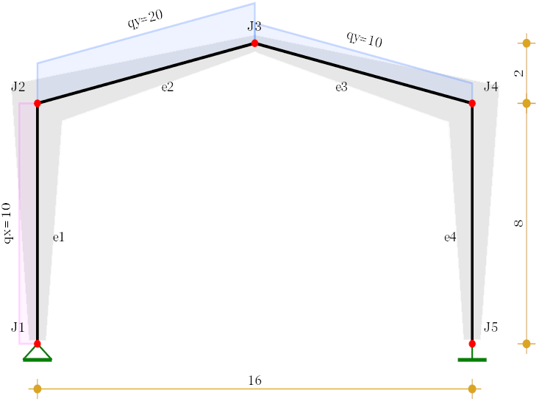
Materials
Modules of elasticity -
Poisson coefficients -
Shear modules -
Assignment on elements -
Cross-sections
Section S1 - ,
Section S2 - ,
General representation
Width -
Height -
Cross section properties
Area -
First moment of area -
Centroid -
Second moment of area -
First moment of area bellow z -
Shear area -
Element stiffness matrix
Elastic properties for element "e"
, ,

Stiffness matrix for element with variable cross-section
Displacement due to Fx = 1 in primary system -
Displacement due to Fy1 = 1 in primary system, with account for shear deflections -
Rotation due to Fy1 = 1 in primary system -
Displacement due to M1 = 1 in primary system -
Rotation due to M1 = 1 in primary system -
Determinant -
Displacement due to Fy2 = 1 in primary system -
Rotation due to Fy2 = 1 in primary system -
Displacement due to M2 = 1 in primary system -
Rotation due to M2 = 1 in primary system -
Determinant -
3x3 blocks of the stiffness matrix for element "e"

Full element stiffness matrix

Stiffness matrices obtained in local coordinates

Stiffness matrices obtained in global coordinates

Global stiffness matrix

Element load vector
Load functions
Lateral -
Axial -
Functions of internal forces in primary system
Axial forces -
Shear forces -
Bending moment -
Reactions at element ends
Displacements along “x“ due to axial loads -
Displacements along “y“ due to lateral loads -
Rotations due to lateral loads -
Element endpoint loads in local coordinate system
For joint “1”: | For joint “2”:
Element endpoint loads in global coordinate system
For joint “1”: | For joint “2”:
Element load vector

Global load vector

Results
Solution of the system of equations

Joint displacements

Support reactions
,

Joint J1 -
Joint J5 -
Element end forces

Element internal forces

Axial forces diagram, kN

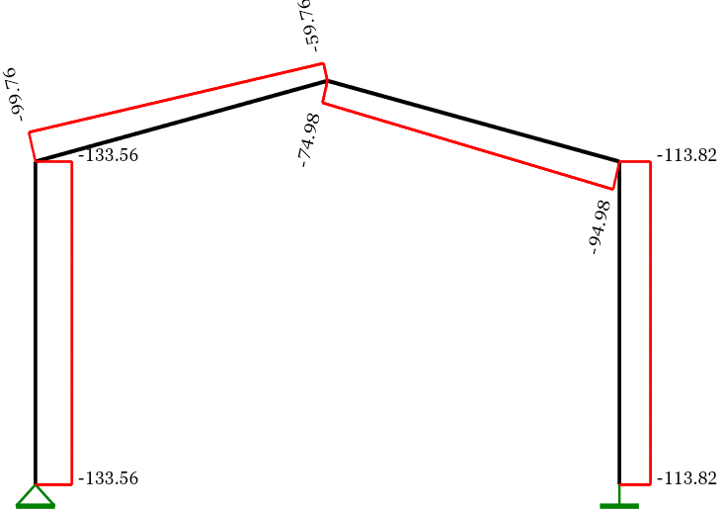
Shear forces diagram, kN

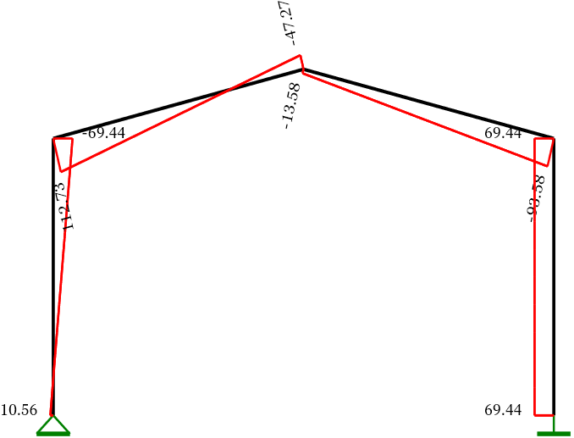

Bending moments diagram, kNm

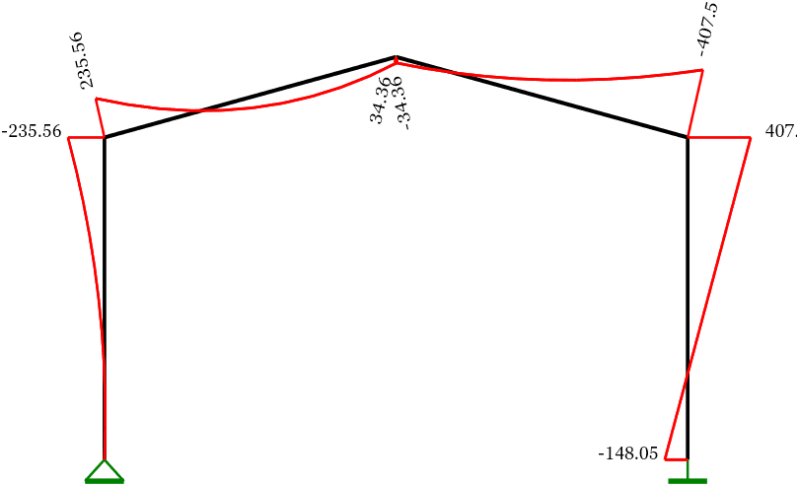
Deformed shape
Shape function in relative coordinates ξ = x/l (approximate)
,
,
Element endpoint displacements and rotations

, ,
, ,
Displacement functions

Deformed shape, mm
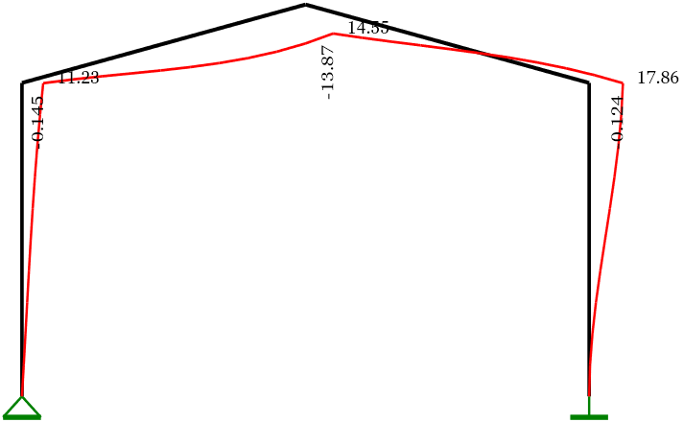

Comparison with SAP 2000
To verify the obtained results, a SAP 2000 model is developed for the same structure. A non-prismatic finite element with three intermediate points is used. The input and output data from the analysis is listed below in both text and graphics.
Input data:
S T A T I C L O A D C A S E S
STATIC CASE SELF WT
CASE TYPE FACTOR
LOAD1 DEAD 0.0000
J O I N T D A T A
JOINT GLOBAL-X GLOBAL-Y GLOBAL-Z RESTRAINTS ANGLE-A ANGLE-B ANGLE-C
1 -8.00000 0.00000 0.00000 1 1 1 0 0 0 0.000 0.000 0.000
2 -8.00000 0.00000 8.00000 0 0 0 0 0 0 0.000 0.000 0.000
3 8.00000 0.00000 0.00000 1 1 1 1 1 1 0.000 0.000 0.000
4 8.00000 0.00000 8.00000 0 0 0 0 0 0 0.000 0.000 0.000
5 0.00000 0.00000 10.00000 0 0 0 0 0 0 0.000 0.000 0.000
F R A M E E L E M E N T D A T A
FRAME JNT-1 JNT-2 SECTION ANGLE RELEASES SEGMENTS R1 R2 FACTOR LENGTH
1 1 2 VAR1 0.000 000000 2 0.000 0.000 1.000 8.000
2 3 4 VAR1 0.000 000000 2 0.000 0.000 1.000 8.000
3 5 2 VAR2 0.000 000000 2 0.000 0.000 1.000 8.246
4 5 4 VAR2 0.000 000000 2 0.000 0.000 1.000 8.246

M A T E R I A L P R O P E R T Y D A T A
MAT MODULUS OF POISSON'S THERMAL WEIGHT PER MASS PER
LABEL ELASTICITY RATIO COEFF UNIT VOL UNIT VOL
STEEL 199947979 0.300 1.170E-05 76.820 7.827
CONC 45000.000 0.200 9.900E-06 0.000 0.000
OTHER 24821128.4 0.200 9.900E-06 23.562 2.401
MAT1 45000.000 0.200 1.170E-05 0.000 0.000
MAT2 35000.000 0.300 1.170E-05 0.000 0.000
F R A M E S E C T I O N P R O P E R T Y D A T A
SECTION MAT SECTION DEPTH FLANGE FLANGE WEB FLANGE FLANGE
LABEL LABEL TYPE WIDTH THICK THICK WIDTH THICK
TOP TOP BOTTOM BOTTOM
VAR1
FSEC10 MAT1 0.300 0.300 0.000 0.000 0.000 0.000
FSEC11 MAT1 0.600 0.300 0.000 0.000 0.000 0.000
FSEC12 MAT1 0.900 0.300 0.000 0.000 0.000 0.000
VAR2
FSEC20 MAT2 0.300 0.300 0.000 0.000 0.000 0.000
FSEC21 MAT2 0.600 0.300 0.000 0.000 0.000 0.000
FSEC22 MAT2 0.900 0.300 0.000 0.000 0.000 0.000
F R A M E S E C T I O N P R O P E R T Y D A T A
SECTION AREA TORSIONAL MOMENTS OF INERTIA SHEAR AREAS
LABEL INERTIA I33 I22 A2 A3
FSEC10 9.000E-02 1.141E-03 6.750E-04 6.750E-04 7.500E-02 7.500E-02
FSEC11 0.180 3.708E-03 5.400E-03 1.350E-03 0.150 0.150
FSEC12 0.270 6.401E-03 1.823E-02 2.025E-03 0.225 0.225
FSEC20 9.000E-02 1.141E-03 6.750E-04 6.750E-04 7.500E-02 7.500E-02
FSEC22 0.270 6.401E-03 1.823E-02 2.025E-03 0.225 0.225
FSEC21 0.180 3.708E-03 5.400E-03 1.350E-03 0.150 0.150
F R A M E S E C T I O N P R O P E R T Y D A T A
SECTION S ECTION MODULII PLASTIC MODULII RADII OF GYRATION
LABEL S33 S22 Z33 Z22 R33 R22
FSEC10 4.500E-03 4.500E-03 6.750E-03 6.750E-03 8.660E-02 8.660E-02
FSEC20 4.500E-03 4.500E-03 6.750E-03 6.750E-03 8.660E-02 8.660E-02
FSEC22 4.050E-02 1.350E-02 6.075E-02 2.025E-02 0.260 8.660E-02
FSEC11 1.800E-02 9.000E-03 2.700E-02 1.350E-02 0.173 8.660E-02
FSEC21 1.800E-02 9.000E-03 2.700E-02 1.350E-02 0.173 8.660E-02
FSEC12 4.050E-02 1.350E-02 6.075E-02 2.025E-02 0.260 8.660E-02
F R A M E S P A N D I S T R I B U T E D L O A D S Load Case LOAD1
FRAME TYPE DIRECTION DISTANCE-A VALUE-A DISTANCE-B VALUE-B
3 FORCE GLOBAL-Z 0.0000 -20.0000 1.0000 -20.0000
4 FORCE GLOBAL-Z 0.0000 -10.0000 1.0000 -10.0000
1 FORCE GLOBAL-X 0.0000 10.0000 1.0000 10.0000

Results:
J O I N T D I S P L A C E M E N T S
JOINT LOAD U1 U2 U3 R1 R2 R3
1 LOAD1 0 0 0 0 1.17 0
2 LOAD1 10.80 0 -0.15 0 2.13 0
3 LOAD1 0 0 0 0 0 0
4 LOAD1 17.26 0 -0.12 0 0.51 0
5 LOAD1 14.04 0 -13.53 0 -1.87 0
J O I N T R E A C T I O N S
JOINT LOAD F1 F2 F3 M1 M2 M3
1 LOAD1 -10.6271 0.0000 133.6357 0.0000 0.0000 0.0000
3 LOAD1 -69.3729 0.0000 113.7507 0.0000 -149.2315 0.0000
F R A M E E L E M E N T F O R C E S
FRAME LOC P V2 V3 T M2 M3
1 0.00 -133.64 10.63 0.00 0.00 0.00 0.00
4.00 -133.64 -29.37 0.00 0.00 0.00 37.49
8.00 -133.64 -69.37 0.00 0.00 0.00 234.98
2 0.00 -113.75 69.37 0.00 0.00 0.00 149.23
4.00 -113.75 69.37 0.00 0.00 0.00 -128.26
8.00 -113.75 69.37 0.00 0.00 0.00 -405.75
3 0.00 -59.71 -47.18 0.00 0.00 0.00 35.66
4.12 -79.71 32.82 0.00 0.00 0.00 65.26
8.25 -99.71 112.82 0.00 0.00 0.00 -234.98
4 0.00 -74.89 13.53 0.00 0.00 0.00 35.66
4.12 -84.89 53.53 0.00 0.00 0.00 -102.58
8.25 -94.89 93.53 0.00 0.00 0.00 -405.75
Labels of joints and elements
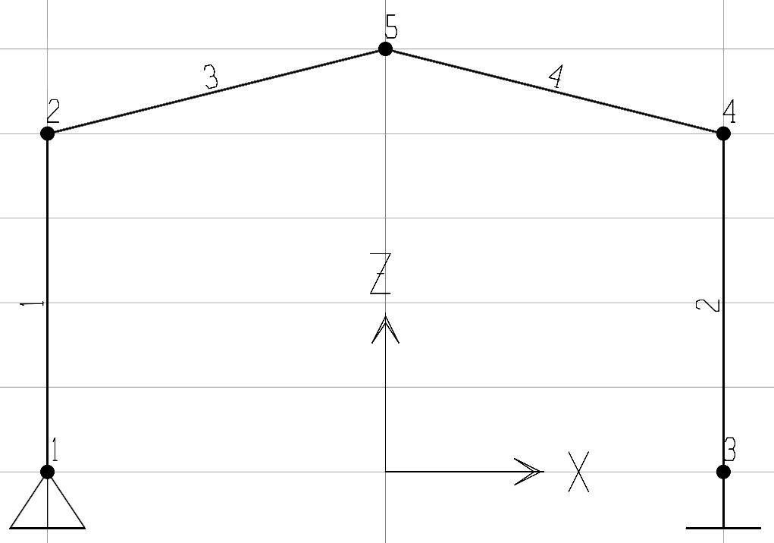

Loads and cross sections
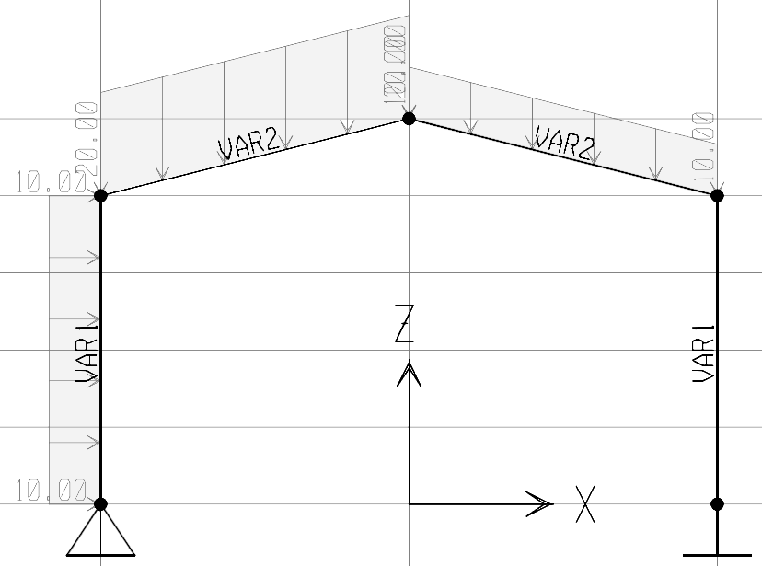
Support reactions
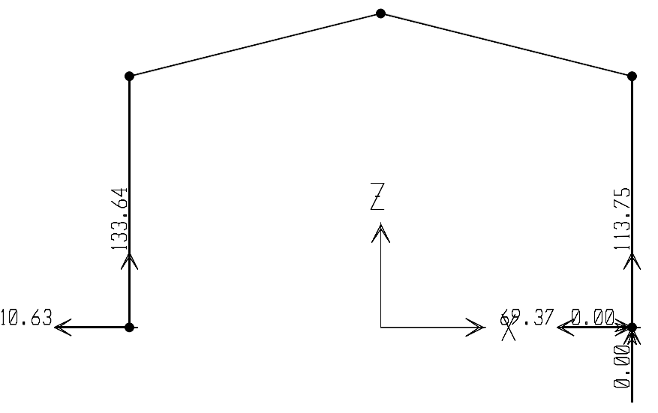
Axial forces
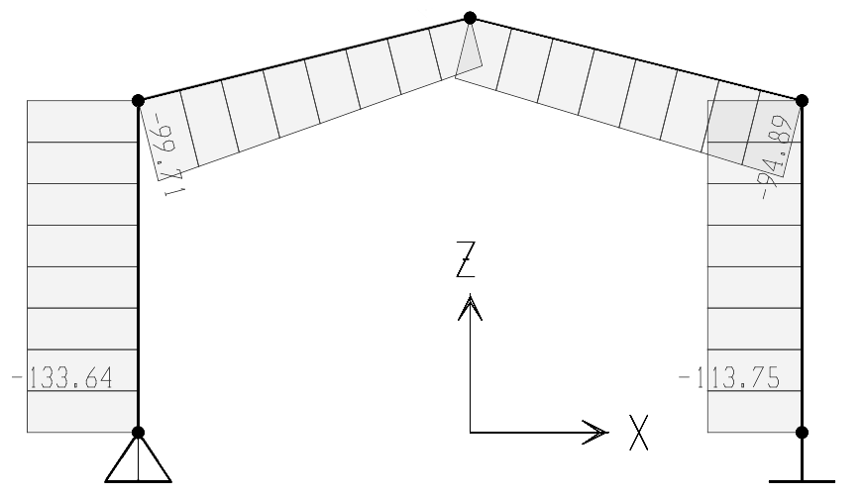

Shear forces
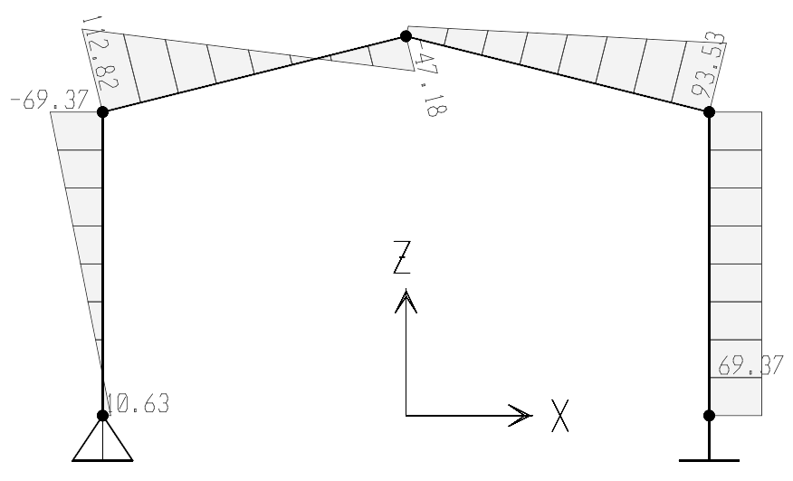
Bending moments
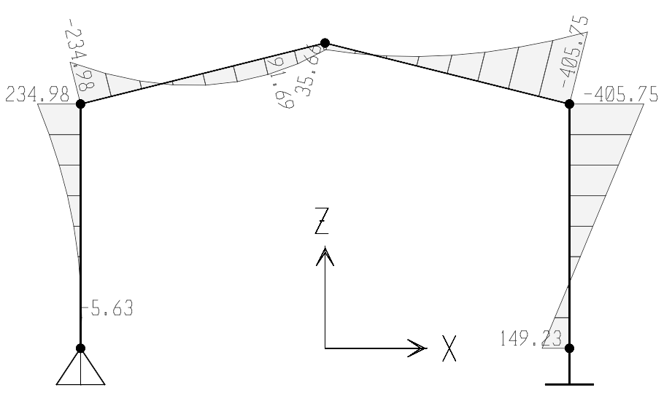

Conclusions
The results obtained by the SAP 2000 software match the Calcpad solution with an accuracy of 0.5%. This is likely due to the different way the elastic properties are approximated along the element length.

